**TAEKWON-DO IMPACT**

43 Guildersfield Road, London SW16 5LS

Web: www.tkdimpact.co.uk

Email: [info@tkdimpact.co.uk](mailto:info@tkdimpact.co.uk)

Tel: +44 208 6790526

31st January 2013

Dear Instructor,

**MASTER WILLY VAN DE MORTEL VII DAN & MR TOMASZ BARADA**

**SPARRING SEMINAR**

**8th & 9th June 2013**

**Master Willy van de Mortel**

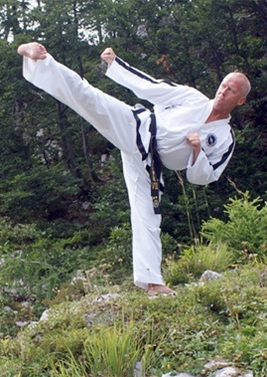

**Coach of legends to both Mr Tomasz Barada**

**and Ms Julia Cross**

**Tomasz Barada**

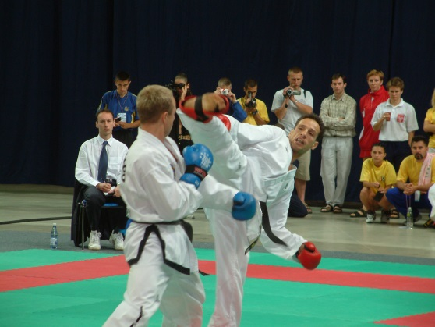

**3 x World Champion**

**6 x European Champion**

**3 x King of Taekwon-Do (Japan Open)**

**6 x W.A.K.O European Champion**

**5 x WAKO World Champion**

**Holds WAKO record of 84 fights without a loss**

**Retired Undefeated in WAKO**

It is with great pleasure that you and your students are invited to a fantastic seminar with Master Willy van de Mortel and Mr Tomasz Barada.

Please take the time to read the following information – please pass on relevant information to your students. If you have any queries please do not hesitate to contact us at the above details. We look forward to seeing you at the seminar.

Yours in Taekwon-Do,

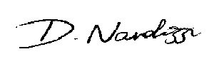

Master Donato Nardizzi

Taekwon-Do Impact

**1.0 Venue, Dates and accommodation**

**1.1 Dates**

There will be 3 x separate seminar as follows:

Saturday 8th June 10.30am - 12.30 am Children aged 8 years to 12 years 6th kup to Blackbelt

Saturday 8th June 2.00pm - 5.00pm Adults and Teen aged 13 years upwards, 6th kup to 1st kup

Sunday 9th June 10.00am - 1.00pm Adults and Teen aged 13 years upwards, Black Belts 1st Degree upwards.

**1.2 Venue**

The seminar will be held at the University of Brighton Sports Centre, Falmer, Brighton BN1 9PH

**1.3 Parking**

There are no parking facilities by the Sports Centre and all cars should be parked in the lower car park. There are NO clamping restrictions in the evenings or at weekends.

**2.1 PARTICIPANTS**

The seminar is open to all ITF England members with a valid license and insurance.

All ITF practitioners are warmly welcome, please contact us for details.

You will need to have: Taekwon-Do dobok, full set of protective equipment.

**3.1 SEMINAR FEES**

Children aged 8 years to 12 years, 6th Kup to Blackbelt; £30.00

Adults and Teens, 6th Kup and 1st Kup; £45.00

Adults and Teens, Black Belts, £45.00

**4.0 BOOKING AND DEADLINE**

Please complete the attached Excel Sheet entry form.

Please email the form and forward payment to the Impact Office. Cheques should be made payable to ‘TKD Impact Ltd’ – only instructor cheques are permissible. Bank transfers to: Sort Code: 60-20-39 Account No: 50661817

IBAN: GB18NWBK60203950661817 BIC/SWIFT: NWBKGB2148V

We have a limited number of places in each seminar of 200 places. We are anticipating this to be a very popular seminar and if you wish to reserve places for your students then early booking is recommended.

The closing date for this competition is **Wednesday 8th May 2013.** The Participant Registration From (sent in Excel format by email only) and payment must reach the Impact Office by this date. Please note that no entries will be accepted after this date.